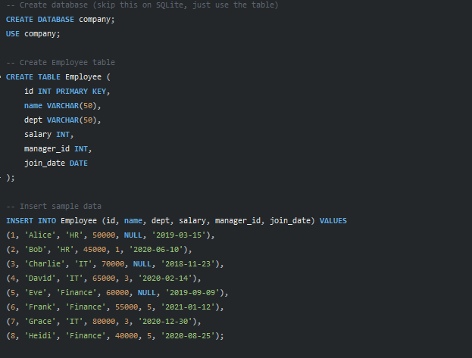

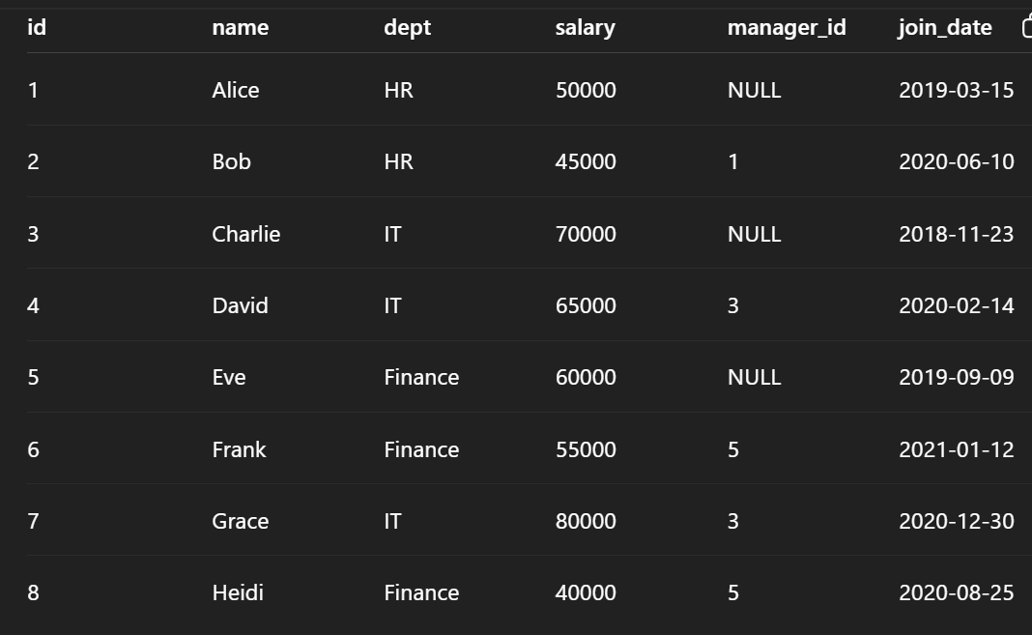

Q1

Max which is less than max

Q2
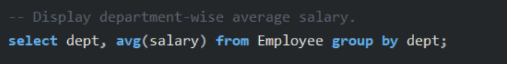

Q3
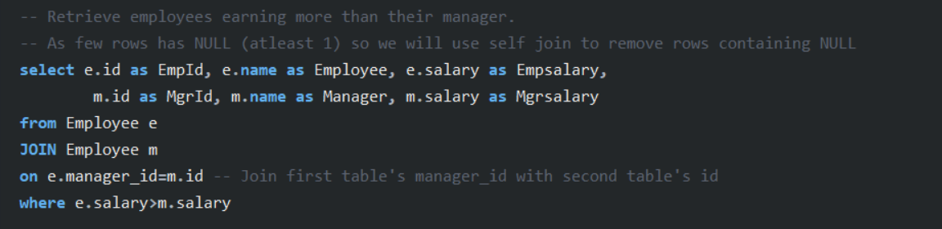
Inner join is used, as we have to compare within the table,
it is joined based on
- Manager_id of first table with ID of second, so we get only those who has manager(who is under manager)
FROM THIS:
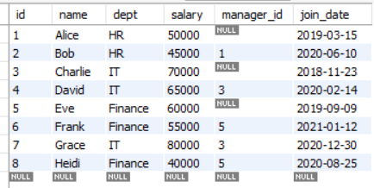

e Join based on m
e.id,e.name,e.salary e.manager_id=m.id m.id,m.name,m.salary

TO THIS:
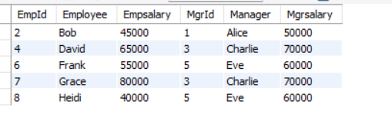

INNER JOIN
Inner Join is used when we just want to matching rows from both tables
like only matching.
Only rows where the primary and foreign key matches
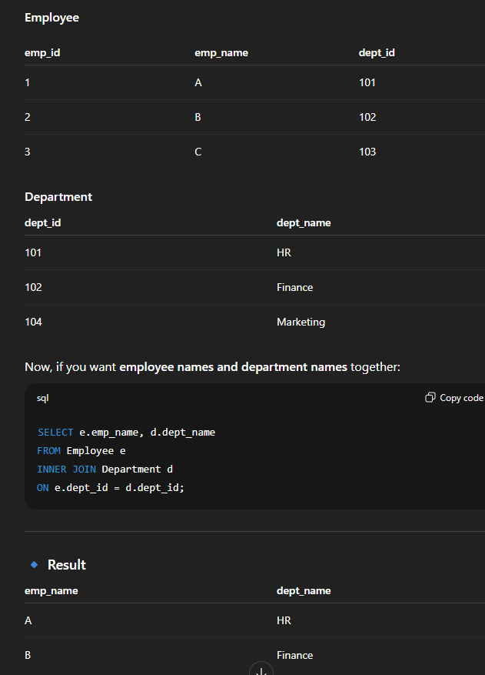

Yes 👍, your thumb rule is right:
- WHERE → filters before grouping.
- HAVING → filters after grouping (with aggregates like COUNT, SUM, AVG).

8️⃣ AVG inside WHERE
You were close. Your thought “find avg in one go and compare” is correct in words.
But SQL doesn’t allow avg(salary) in WHERE directly — it forces you to write it as a subquery.
So:
select emp_name
from employee
where salary > (select avg(salary) from employee);
👉 The inner query is executed once, then compared row by row.
So your mental model was correct ✅, just SQL syntax rules stopped you.

SO SUBQUERY EXECUTES IN ONE GO AND COMPARE WITH OUTER QUERY ONE BY ONE

🟢 Golden SQL Rules (Keep Handy for Tests)
1️⃣ WHERE vs HAVING
- WHERE → filters rows before grouping.
- HAVING → filters groups after aggregation.
✅ Rule: If using COUNT/AVG/SUM/MAX etc. → use HAVING, not WHERE.

2️⃣ INNER JOIN vs LEFT JOIN vs RIGHT JOIN
- INNER JOIN → only matching rows from both tables.
- LEFT JOIN → all rows from left, matched rows from right.
- RIGHT JOIN → all rows from right, matched rows from left.
✅ Rule: Avoid RIGHT JOIN → just swap table order & use LEFT JOIN (more standard).

3️⃣ Aggregates in WHERE ❌
- You can’t write WHERE AVG(salary) > 50000.
- Must use a subquery:
WHERE salary > (SELECT AVG(salary) FROM employee)

4️⃣ GROUP BY Rule
- Every non-aggregate column in SELECT must appear in GROUP BY.
✅ Rule: SELECT dept_id, AVG(salary) → must GROUP BY dept_id.

5️⃣ NULL Handling
- = or != doesn’t work with NULL.
✅ Rule: Always use IS NULL or IS NOT NULL.

6️⃣ Subquery Execution
- Subqueries execute first, pass a single value or result set to outer query.
✅ Rule: Mental model → “Inner query result is compared row by row”.

7️⃣ Self Join Use Case
- Compare rows within the same table (like employee vs manager).
✅ Always alias tables (e1, e2) to avoid confusion.

8️⃣ ORDER of Execution (helps avoid confusion)
- FROM / JOIN
- WHERE
- GROUP BY
- HAVING
- SELECT
- ORDER BY
✅ Rule: This explains why WHERE can’t use aggregates (they’re not calculated yet).

9️⃣ DISTINCT vs GROUP BY
- Both remove duplicates.
- Use DISTINCT for simple uniqueness.
- Use GROUP BY when using aggregates.

🔟 LIMIT / TOP usage
- LIMIT (MySQL, PostgreSQL) → LIMIT 5.
- TOP (SQL Server) → SELECT TOP 5.
✅ Rule: Always check DB flavor before exam

ANSI SQL
Q Find the average salary department-wise.
every non-aggregated column in SELECT must appear in GROUP BY.

